One Hot Encoding

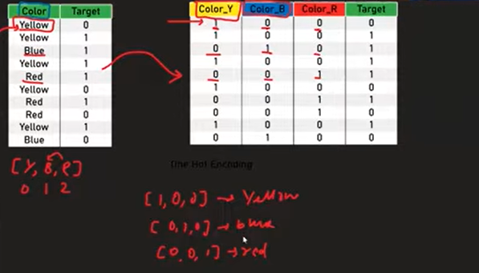

1. What is One-Hot Encoding?
- One-Hot Encoding (OHE) is a technique used to convert Nominal Categorical Data into numerical form.
- It creates one new binary column for each category.
- Machine Learning algorithms cannot understand text, so OHE converts text into numbers.

2. Why One-Hot Encoding is Needed?
Machine Learning algorithms work only with numerical values.
Example:
Color
Red
Blue
Yellow
The algorithm cannot process these text values directly.

3. Nominal vs Ordinal Data

Nominal Data
- No order or ranking.
- Examples:
  - Gender
  - City
  - Color
  - Brand
Use: One-Hot Encoding

Ordinal Data
- Categories have a meaningful order.
- Examples:
  - Poor < Average < Good
  - School < UG < PG
Use: Ordinal Encoding

4. How One-Hot Encoding Works
Suppose we have:
Color
Red
Blue
Yellow
Create one column for each category.
Color_Red | Color_Blue | Color_Yellow
1 | 0 | 0
0 | 1 | 0
0 | 0 | 1
Each row has:
- 1 → Category is present.
- 0 → Category is absent.

5. Example
Before Encoding
Fuel
Petrol
Diesel
CNG
After Encoding
Petrol | Diesel | CNG
1 | 0 | 0
0 | 1 | 0
0 | 0 | 1

6. Why Not Use Ordinal Encoding for Nominal Data?
If we encode:
Color
Yellow
Blue
Red
as
Yellow → 0

Blue → 1

Red → 2
The model may think:
Red > Blue > Yellow
which is incorrect because colors have no order.
Therefore, use One-Hot Encoding.

7. Dummy Variable Trap

What is it?
After One-Hot Encoding, all columns become dependent.
Example:
Red | Blue | Yellow
1 | 0 | 0
0 | 1 | 0
0 | 0 | 1
Notice:
Red + Blue + Yellow = 1
One column can always be predicted from the others.
This is called the Dummy Variable Trap.

Solution
Remove one encoded column.
Instead of
Red | Blue | Yellow
Use
Blue | Yellow
Now:
Blue | Yellow
0 | 0
1 | 0
0 | 1
Only k − 1 columns are needed.

8. Why Remove One Column?
To avoid:
- Multicollinearity
- Redundant information
- Problems in Linear Regression and Logistic Regression

9. Large Number of Categories
Sometimes a column has many categories.
Example:
Brand
-------
Maruti
Honda
BMW
Ford
Jaguar
Volvo
Skoda
...
If there are 50 brands, One-Hot Encoding creates 50 new columns.
This increases:
- Memory usage
- Training time
- Dataset size

10. Solution for High Cardinality
Keep only the most frequent categories.
Group all rare categories into one category called:
Others
Example
Before
Maruti
Honda
BMW
Jaguar
Volvo
Bentley
Ferrari
After
Maruti
Honda
BMW
Others
This reduces the number of columns.

11. One-Hot Encoding using Pandas
Import Pandas
import pandas as pd
Perform One-Hot Encoding
pd.get_dummies(df, columns=['Fuel', 'Owner'])

Remove Dummy Variable Trap
pd.get_dummies(
df,
columns=['Fuel','Owner'],
drop_first=True
)
drop_first=True removes the first category.

12. One-Hot Encoding using Scikit-Learn
Import
from sklearn.preprocessing import OneHotEncoder
Create Encoder
ohe = OneHotEncoder()
Fit and Transform
X_train_new = ohe.fit_transform(
X_train[['Fuel','Owner']]
)
Transform Test Data
X_test_new = ohe.transform(
X_test[['Fuel','Owner']]
)

13. Useful Parameters

Drop First Column
OneHotEncoder(drop='first')
Removes one column from each feature.

Dense Output
OneHotEncoder(
sparse_output=False
)
Returns a NumPy array instead of a sparse matrix.

Integer Output
OneHotEncoder(
dtype=int
)
Produces integer values (0 and 1).

14. Train-Test Rule
Always:
- Split data.
- Fit only on training data.
- Transform both training and testing data.
ohe.fit(X_train)

X_train = ohe.transform(X_train)

X_test = ohe.transform(X_test)

15. Advantages
- Correctly handles nominal data.
- No false ordering is introduced.
- Improves model performance.
- Easy to understand.
- Widely used in Machine Learning.

16. Disadvantages
- Creates many new columns.
- Increases dataset size.
- Slower for datasets with many categories.
- Can cause the Dummy Variable Trap if all columns are kept.

17. Important Exam Points
- One-Hot Encoding (OHE) converts Nominal Categorical Data into numerical form.
- Creates one binary column for each category.
- Uses 0 and 1 values.
- Do not use Ordinal Encoding for nominal data.
- Dummy Variable Trap occurs because encoded columns become dependent.
- Remove one encoded column using drop='first' or drop_first=True.
- For features with many categories (high cardinality), group infrequent categories into "Others" before applying One-Hot Encoding.
- Common implementations:
  - Pandas: pd.get_dummies()
  - Scikit-Learn: OneHotEncoder()

